
CLEAR REFLECTION
Welcome to [Clear Reflection], where we specialize in high-quality LED mirrors designed to enhance your space with elegance and functionality. With a passion for innovation and customer satisfaction, we bring you the perfect blend of modern technology and stylish design, offering a product range that suits every need. |  | 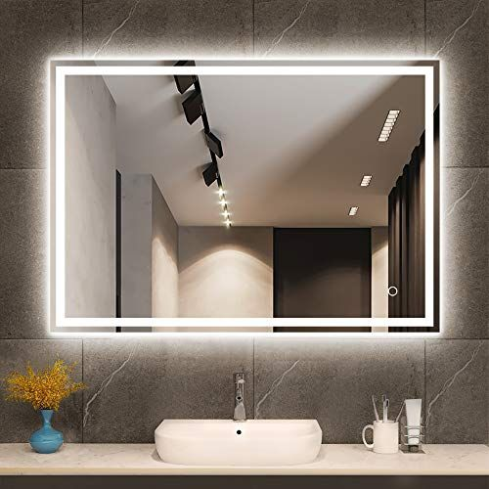  Description
• Premium Quality: Our LED mirrors are made from durable materials, offering both clarity and longevity.
• Modern Designs: We offer a variety of stylish and contemporary designs to match any decor.
• Energy-Efficient: All our mirrors feature energy-saving LED technology, reducing your environmental footprint.
• Affordable Pricing: We believe in providing exceptional quality at competitive prices. Our LED mirrors are designed to suit every budget.

